FORMULA BHARAT

**BRAKES DESIGN**

**Introduction**

The purpose of this report is to outline the design considerations and decisions made for the brake system of a formula student vehicle. The brake system is a critical component that directly affects the vehicle's performance, safety, and handling characteristics.

**Design Objectives**

The design objectives for the brake system were as follows:

* Achieve optimal braking performance with a focus on deceleration rate, stopping distance, and brake balance.
* Minimize weight while ensuring safety and reliability.
* Comply with Formula Bharat competition regulations regarding brake components, performance, and safety.

**Brake Components**

The brake system comprises several key components, including:

* Brake Callipers: Lightweight, forged aluminium callipers were selected to reduce unsprung weight while providing sufficient clamping force. The callipers feature dual pistons for improved braking modulation. The callipers are dual piston fixed callipers of piston diameter 32 mm at front and 25.4 mm at rear.
* Brake Rotors: Rotors with a slotted design were chosen to dissipate heat effectively and prevent brake fade. The diameter was determined based on vehicle weight, speed, and desired deceleration performance. The diameter of the disc rotor is 180 mm.
* Brake Pads: High-performance brake pads with a suitable friction material were selected to provide consistent braking performance, good pedal feel, and minimal pad wear.
* Brake Lines: Stainless steel braided brake lines were chosen for their durability, resistance to expansion, and improved pedal feel. The lines were routed to minimize pressure drop and ensure efficient fluid flow.

**Brake System Design**

* Brake Bias: The vehicle's weight distribution will be analysed, and brake bias was calculated to achieve the desired front-to-rear brake balance. Brake bias was done by using different piston diameter callipers are front and rear.
* Master Cylinder and Pedal Assembly: The bore diameter and pedal ratio were optimized to achieve the desired pedal feel and modulation. The master cylinder diameter is 15 mm to get the desired pressure inside the master cylinder. The pedal ratio is 6:1 based on the space constraints.
* Brake Fluid: A high-quality brake fluid (DOT4) with a high boiling point was chosen to withstand the heat generated during braking and resist moisture absorption. Regular fluid flushes and inspections were scheduled to maintain performance and safety.

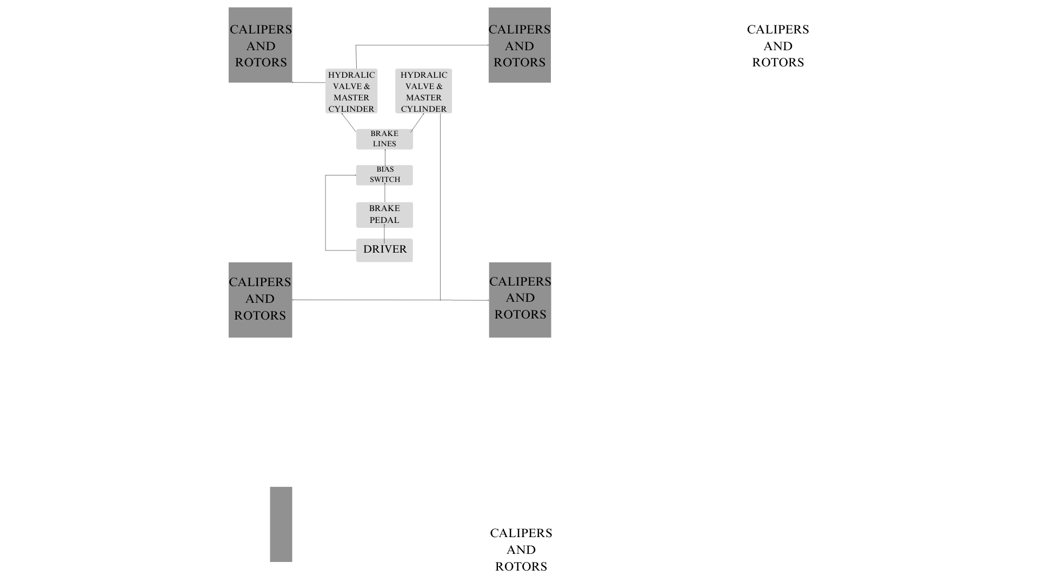

**Conclusion**

* The brake system design for the formula student car was carefully considered, keeping performance, weight, safety, and compliance with competition regulations in mind. Through component selection, system optimization, and thorough testing, the brake system will achieve the desired braking performance, reliable operation, and safety requirements for competitive formula student events.